Smart Expense Tracker – Django-Based Web Application for Personal Expense Management
Author: Vinaya(TEAM 2)
Project Type: Mini Project

EXECUTIVE SUMMARY
The Smart Expense Tracker project demonstrates the development of a lightweight web application built using Django, designed to help users digitally manage and monitor personal expenses. The system allows users to securely log daily expenses by entering description, amount, date, and optional notes. Each expense is automatically categorized using smart keyword-based prediction logic.
With increasing financial activities and spending patterns, manual tracking becomes difficult and inefficient. This project addresses the problem by creating a structured digital system that organizes expense records, enables filtering based on time periods, and visualizes spending patterns through charts and dashboards.
The application provides a scalable and user-friendly solution for personal budgeting and financial awareness while ensuring secure user authentication and user-specific data privacy.

PROJECT OVERVIEW
Objective
To develop a Django-based web application that allows users to digitally record, categorize, visualize, and manage personal expenses efficiently.
Scope
• Digital logging of personal expenses
• Smart category prediction using keyword matching
• Date-wise filtering of expenses
• Expense editing and deletion
• Graphical visualization of spending behavior
• CSV/PDF report download support
• Secure user authentication and session management

KEY FEATURES
• User Authentication: Secure signup, login, and logout system using Django authentication.
• Add Expense: Users can add expense details including description, amount, date, and notes.
• Smart Category Prediction: The system predicts categories automatically using keywords such as Pizza → Food and Uber → Travel.
• Expense Filtering: Expenses can be filtered by Today, Week, and Month.
• Edit/Delete Expenses: Users can update incorrect records or remove unnecessary entries.
• Expense Visualization: Pie charts and bar graphs show category-wise and total expenses.
• Download Reports: Users can export expense data into CSV format for offline access.

TECHNICAL IMPLEMENTATION
Architecture
1. Input Layer → User enters expense details through web forms
2. Routing Layer → Django URLs handle requests and direct them to views
3. Database Layer → Django ORM stores and retrieves records from SQLite
4. Smart Prediction Layer → Keyword matching logic predicts expense categories
5. Visualization Layer → Chart.js generates graphs and charts dynamically
6. Authentication Layer → Django authentication secures user accounts and sessions
Technology Stack
• Python 3.x – Core programming language
• Django – Backend web framework
• SQLite – Lightweight database system
• HTML5/CSS3 – Frontend development
• Bootstrap – Responsive UI design
• Chart.js – Expense visualization library
• Jinja/Django Templates – Dynamic HTML rendering

DATABASE MODEL
• User ID
• Expense Description
• Amount
• Category
• Date
• Notes
Key Operations (CRUD)
• Create – Add new expense entries
• Read – View expense history and analytics
• Update – Edit existing expense details
• Delete – Remove unwanted expense records

PERFORMANCE METRICS
• Processing Capacity: Supports multiple user expense entries and filtering operations
• Execution Time: Fast page rendering and database operations using SQLite
• Visualization Speed: Instant chart generation for expense analysis
• Accuracy: Reliable CRUD operations using Django ORM
• Evaluation Metrics: Functional correctness, UI responsiveness, and data security

SOURCE CODE IMPLEMENTATION
The application is implemented using Django views, models, forms, templates, and URL routing. Expense data is managed through Django ORM and rendered dynamically using Bootstrap-based templates.
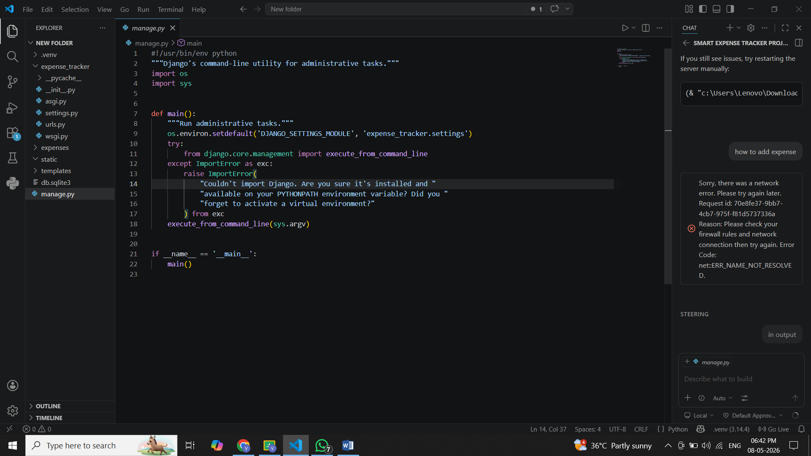

OUTPUT SCREENSHOTS
• Login Page
• Registration Page
• Dashboard
• Add Expense Page
• Expense Charts
• Download Report Feature
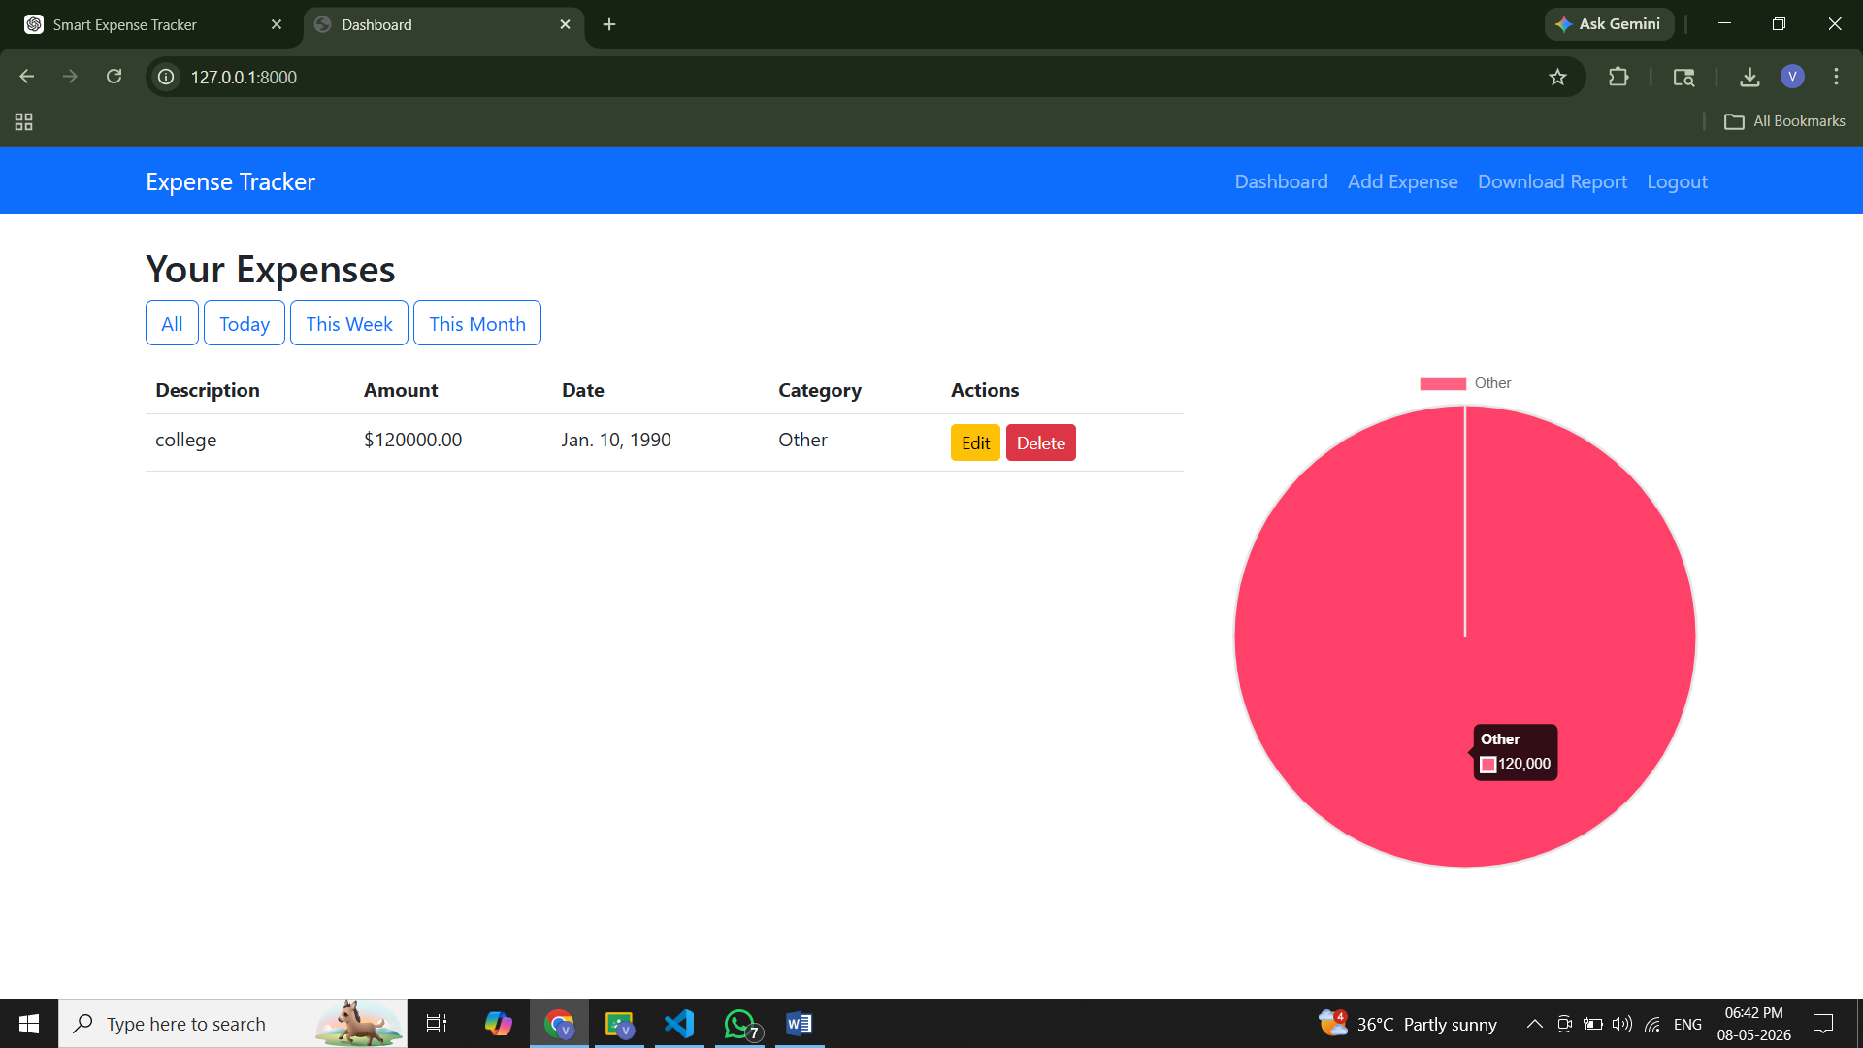

KEY ACHIEVEMENTS
Technical Accomplishments
• Successfully developed a fully functional Django web application with CRUD operations
• Implemented SQLite database integration using Django ORM
• Integrated Chart.js for graphical visualization of expense data
• Developed smart category prediction using keyword matching
• Designed a responsive Bootstrap-based user interface
Process Automation Benefits
• Automated Expense Management: Eliminates manual tracking using notebooks or spreadsheets
• Better Financial Awareness: Helps users analyze spending habits visually
• Secure Data Management: User-specific expense isolation through authentication
• Scalability: Can be enhanced with AI, cloud integration, and mobile support

LIMITATIONS AND CONSTRAINTS
Current Limitations
• Uses basic keyword matching instead of advanced AI/NLP prediction
• SQLite is not ideal for very large-scale deployments
• No real-time notifications or budget alerts
• No mobile application currently available
Resource Constraints
• Local deployment without cloud hosting
• Limited admin-level analytics and controls
• Performance may vary under very high concurrent usage

PROJECT IMPACT AND VALUE
Immediate Benefits
• Digital Expense Tracking: Replaces manual expense recording methods
• Financial Awareness: Helps users monitor and control spending
• User Convenience: Quick filtering and graphical reports improve usability
• Organized Data Storage: All records are securely maintained in a database
Long-Term Potential
• AI-based Expense Prediction
• Budget Alert Notifications
• Cloud Database Integration
• Android/iOS Mobile Application
• REST API Integration for third-party applications

CONCLUSION
The Smart Expense Tracker project successfully demonstrates the application of Django web development, database integration, and graphical visualization for building a practical personal finance management system. By digitizing expense tracking and automating categorization and reporting, the system offers a significant improvement over traditional manual methods.
The project highlights important concepts including Django routing, authentication, ORM operations, CRUD functionalities, and Chart.js integration, making it an ideal mini project for understanding real-world web application development. With future enhancements such as AI-based analytics, cloud support, and mobile integration, this system has strong potential to evolve into a full-scale financial management platform.

